1. SELECT COUNT(Country) FROM Customers

WHERE Country =‘Germany’

1. SELECT COUNT(CustomerName) FROM Customers

WHERE CustomerName Like '%e’

1. SELECT(CustomerName) FROM Customers

WHERE CustomerName ='Shadrin Vlad'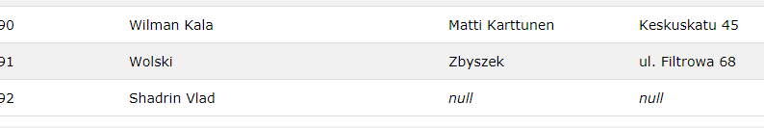

1. UPDATE Customers

SET ContactName = 'Albus Dumbledore'

WHERE CustomerName = 'Shadrin Vlad'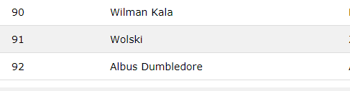

1. DELETE FROM Customers

WHERE City='Nantes'

You have made changes to the database. Rows affected: 2

1. SELECT Orders.OrderID, Employees.EmployeeID

from Orders

Inner join Employees ON Orders.EmployeeID = Employees.EmployeeID

where Employees.FirstName = 'Steven'

